Help yourself to be seen – safe walking and cycling at night

When the clocks go back at the end of October children need to take extra when walking or cycling at night. With our narrow roads, blind bends, lack of footpaths and street lighting it is really important that motorists can see you – and that means you need to brighten up.

Whether you walk or cycle, the best way is to wear a high visibility vest or jacket. At night drivers can see you in a hi-vis vest 3 times further away than if you are in dark clothes. If you don’t want to wear a hi-vis item, wear something bright or light coloured (never black), or if walking, carry a light coloured bag or a torch.

If you are walking in the lanes or in areas where there isn’t a footpath (pavement) you must always walk on the right hand side of the road facing the traffic. This applies at any time of the day but it is particularly important at night because motorists can be blinded by the traffic coming towards them and not see you if you are in the shadows on their side of the road. It also makes sense to face the traffic so that you can see what’s coming towards you and move into the side if necessary.

The only exception is when you approach a right hand blind corner. You should never walk around a blind bend (whether during daylight or at night). The best thing is to carefully cross over the road well before the bend and then cross back again afterwards.

Even if there are footpaths on your walk home there will be times when you need to cross the road so being visible is still important. Also in many narrow roads vehicles have to mount the pavement to let a wide vehicle pass, so being able to see you is crucial.

German road safety research has shown that while 75% of all driving is done during daylight hours, more than 50% of all fatal accidents happen during the hours of darkness. 90% of a driver’s reaction depends on vision, and vision is severely limited at night. Even on well lit roads depth perception, colour recognition, and peripheral vision are compromised after sunset.

A driver travelling at 40mph with dipped headlights has just 1.5 seconds to react to a hazard in the road and 3 seconds on main beams.

A pedestrian knocked down by a vehicle travelling at 40 mph has a 9 out of 10 chance of being killed.

So, please, help yourself to be seen during murky days and at night by wearing something bright or light, or preferably hi-vis. And please follow the rules of the road by never walking with your back to the traffic if there isn’t a footpath. (continued/over)

HIGH VIS – THE FACTS:

Fluorescent materials really glow by reacting with ultra-violet rays in sunlight. Ideal for getting you noticed during the day.

Reflective materials work at night because their special surfaces bounce light back from street and car headlights off hundreds of tiny beads. At night reflective materials can be seen by drivers using headlights up to three times as far away as non-reflective materials.

Road Safety advice by
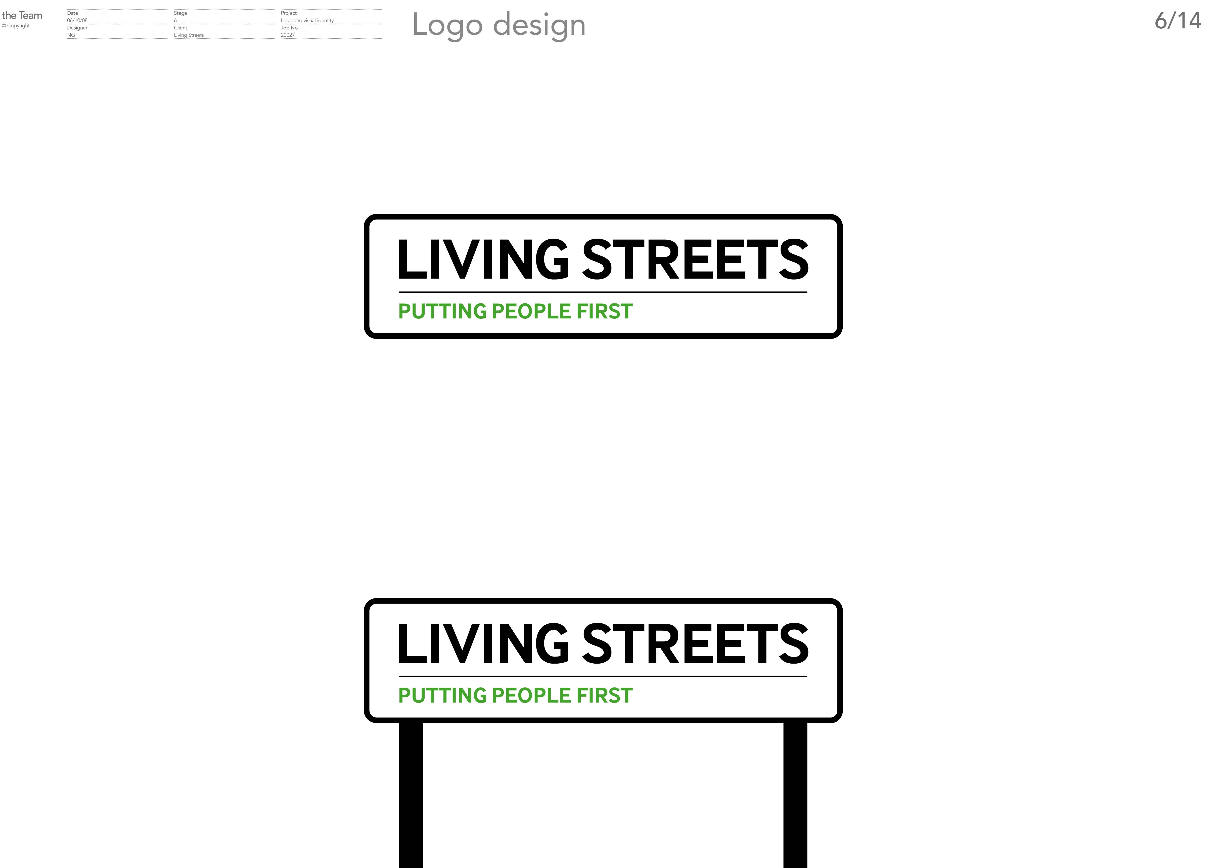

Living Streets is a pedestrian safety group that campaigns for better streets and public places for people on foot. The group chaired the Road Safety Week Committee between 2003 and 2007 and it has run many campaigns over the years in order to try to improve the pedestrian environment in Guernsey. Its current campaign is for a safe cross country route to the Baubigny Schools for children coming from St. Peter Port.
For more information see our website: www.livingstreets.org.gg

Attached photo shows Capelles Youth Forum children being seen at night in their hi-vis gear. Islands Insurance sponsored the hi-vis vests and baseball caps in 2007.

Pat Wisher (Secretary of Living Streets)
5.11.09.

